UNIVERSITY CATERING
ADVANCED DATABASE MANAGEMENT SYSTEMS – (CS -5356-001)
R11916865-NAVYASRI CHERUKURI

Table of Contents:

1.Introduction
1.1Project Overview…………………………………………………………………3
1.2Team Composition……………………………………………………………….3
2.Project Description………………………………………………………………………...4
2.1Database Overview……………………………………………………………..4-5
2.2Technical Specifications………………………………………………………..5-6
2.3Challenges and Solutions……………………………………………………….6
3.Personal Contribution……………………………………………………………………..6
3.1Role and Responsibilities………………………………………………………6-7
3.2Work Process……………………………………………………………………8-10
3.3Technical Implementation……………………………………………………10-11
4.Reflection
4.1Learning Outcomes……………………………………………………………..11
4.2Teamwork and Collaboration…………………………………………………..11
4.3Challenges Faced……………………………………………………………….11
4.4Skills Developed…………………………………………………………………12
4.5Future Application……………………………………………………………….13
5. Conclusion………………………………………………………………………………..13
6. References………………………………………………………………………………..13

1.Introduction
1.1Project Overview
In our University Catering project, we implemented it by using Full Stack Web Application Techniques. This main intention of this web application to provide the interface for the stakeholders to order food online of their choice. The Customers will have various options to select the food from this university Catering web application. This application makes users process ease and helps them to get their chosen food to their door. Users can order their items anytime at their feasible timings. The User interface of this application is user friendly for stakeholders, Admins. Basically, Admins will operate this application to add, delete and edit the items.

1.2Team Composition

SNO | Team Members | Roles
1 | Navyasri Cherukuri | Project Manager/Admin
2 | Jaswanth Babu Dharanikota | Backend Developer
3 | Yasaswini Pamidi | Database Designer
4 | Gnanendra Sai Prasad Pamidi | UI Developer

Every one in our team worked collaboratively and diligently to Deliver this Project on time. Each of us worked on different functionality collectively helped to accomplish this project successfully. Though we have our specific roles yet we had our contribution in other teammates functionality to have a heads up on the entire project. Each of us took the responsibility to contribute efficiently.

2.Project Description
2.1Database Overview
In this application users will login if the authentication is success then he will land on home page. There the user could see various of food items ,he can view the details of the product and if he likes the product then add to cart. On click of cart he could specify the quantity of the items of his choice and on click of check out the orders will be placed successfully.Like as in every application, In our project also Database played a vital role. We used SQL Server Management Studio as a Database tool to perform CRUD operations. We also provided the authentication for the data access and restricted it for only Project Manager. Our project is a Database-First Approach which means we first created the tables that are required for the project and integrated them with the code using Entity Framework in Visual Studio. We altogether have six entities also called tables in our application. Entities have their own attributes. Each of the entity has their primary keys which are also defaulted as clustered indexes. One table is connected to the other is any relation between them via by foreign keys. We also defined some constraints to the tables. The scope of the Database in our project is to maintain the Users data diligently. Processing the payments for the orders placed. To attain better performance of the system we also created non-clustered indices for the tables. The data would be efficiently picked up while doing basic SQL operations with the use of these keys and indices. Query Optimization is our priority.
We also generated an Entity Relationship diagram to have a clear understanding of the entities and their relations. Below is the E-R diagram of our University Catering Application.

Entity Relationship Diagram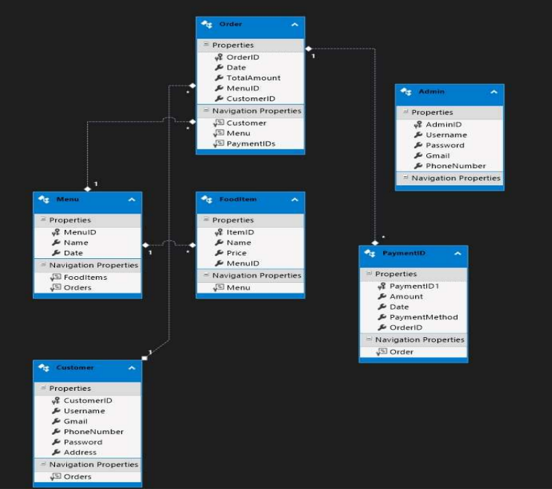

2.2Technical Specifications

Tool | version | purpose
SSMS | 19 | Database
VisualStudio | 2022 | Coding
Sonar | v7.2 | Performance

Technologies | Purpose
C# | Back -End
HTML,CSS | Front-End
.Net MVC | Framework

2.3Challenges and Solutions
During the Development of this system, we faced some challenges in terms of database in terms of Back End connectivity etc. Some of the minor challenges are that since .Net MVC is entirely new to our entire team we faced a bit of challenge while connecting database to the visual Studio server. One of the major challenges is adding references to get NuGet packages in our framework. We are trying to add references of the packages but unfortunately, they keep on missing after we invested some time on understanding about how to load these references and it’s working functionality. The solution we found to overcome this problem is to unload the entire solution in the visual studio and comment on the DLL which is the root cause of our bug. The solution is simple yet difficult to debug that issue. Like wise there are some small, big and small challenges we faced while developing the application. We collaboratively worked very diligently to build the system.

3.Personal Contribution
3.1 Role and Responsibilities
In the process of development of the system I am the project manager and is responsible for Admin Functionality. Admin will have the access to add the product into the database, modify or edit the product details and delete the product from the database. I ‘m responsible for creating the Admin login pages, Admin Invoice pages ,Orders pages. Apart from implementing the Admin Functionality I am also responsible for assigning tasks to the team members based on their strengths and weaknesses. Admin have the access to set the product price i.e food item price in this application. I could also Order lists and stakeholders details in the order list menu. She could also see the invoices list to maintain the application diligently and efficiently. I could also check the past order details of the customer. In the Admin Dashboard I could perform various functionalities such as add a food item ,edit a food item, details of the food item and delete the food item. I am also responsible for development entire admin functionality. I developed all the admin screens which include Home page, list of invoices, list of products and Contact pages.
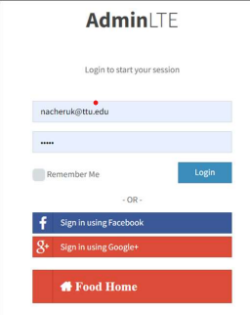

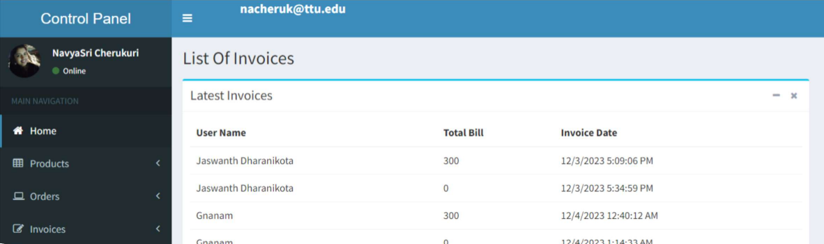

3.2 Work Process
The main task of mine in our Project is to develop the pages for Add the product into the database, Edit the details of the Products ,Delete the details of the product and write some back end code to achieve this. We are using .Net MVC framework to code in. MVC has model view controller architecture.
Development Steps:
1.)I initially gathered the requirements for starting the implementation.
2.)Implemented the Design of the project
3.) then started coding.
4.)Tested the Application
- In specific my contribution is, development of AdminController.cs file I coded in such a way to implement the main business logic. For login functionality, I used post method to fetch all the records from Admin table by using LINQ query and checking with the given credentials by user on View. If the credential matches i.e on success then we return to the view of Admin Page. If fails then remains on same page.
- For Fetching list of invoices I implemented ListOfInvoices Action method where we are summing up the bill amount of all the orders of a particular customer and displaying it on screen.
- For Orders of lists fetching the idea of implementation is to initially check if Admin Cookie exists or not for authorization purpose. I f cookie is present then we are calculating total bill by summing up the Order_Bill values of each order.
- The calculated total order bill (t) is stored in the temptdata dictionary. TempData is a temporary storage mechanism that persists only for the current and subsequent requests.
- For Adding the product Admin will give Product name ,price ,And upload the image of the product and onCLick on add it sits in database I used jquery to do this operation.
- The same is with Edit the product and Delete operations also, I used the Javascript code to make this work.
Below mentioned are the code snippets of the Admin business logic implementation.

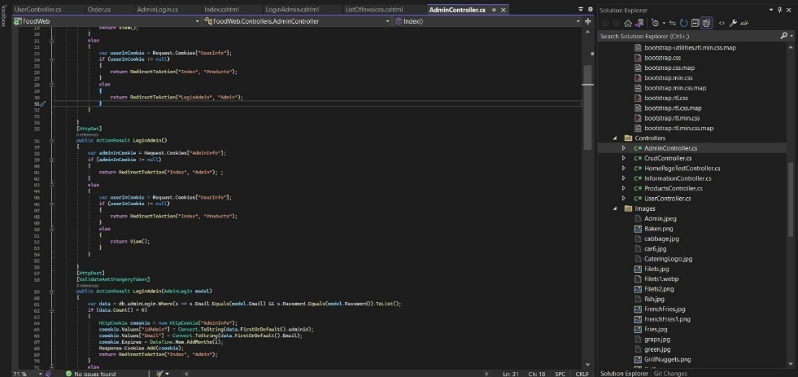
Fig:3.2 a

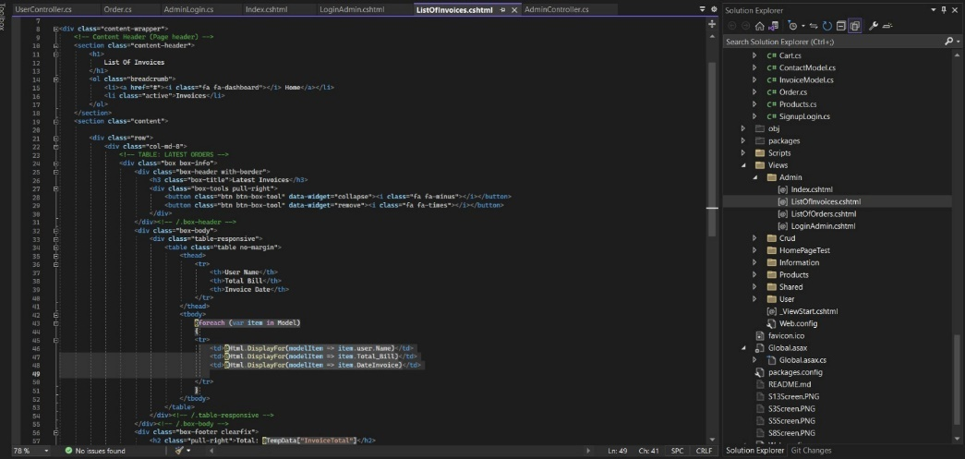
Fig:3.2 b

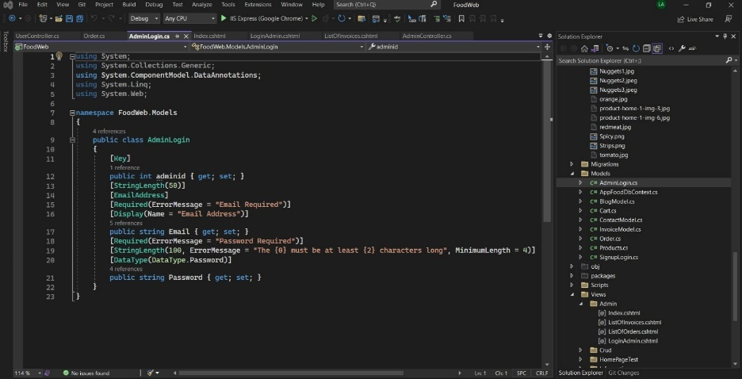
Fig:3.2 c

3.3 Technical Implementation
I created model classes such as AdminLogin.cs, Orders.cs, Products.cs and InvoiceModel.cs which will have attributes of the Admin, Order and Products Entities.Figure 3.2c is used to show how a model appears. These Models represents applications data of the Entities. The controllers which I implemented is AdminController.cs, first I created a class called AdminController.cs and imported the required namespaces. As mentioned in fig 3.3a the layout of MVC required for Admin is shown.The Controller Action methods are Index(), LoginAdmin()[Get], LoginAdmin[GetPost],LogOutAdmin[GetPost],ListOfOrder(),ListOfInvoices().
Index():checking if the administrator's authentication is based on a cookie (AdminInfo). The Index view is returned if the user is authenticated; if not, the user is redirected to their product index, and if neither of them is signed in, they are redirected to the admin login page.
LoginAdmin()[Get]:uses a cookie to determine whether an admin is already logged in and, if so, reroutes to the admin index. The user gets redirected to their product index if they are logged in; else, the admin login view is displayed.
LoginAdmin[GetPost]:sends the admin login request. creates an AdminInfo cookie to store admin data after a successful login and checks credentials against the database. In the event that the login is unsuccessful, an error notice will appear on the login page and the user will be redirected to the admin index.
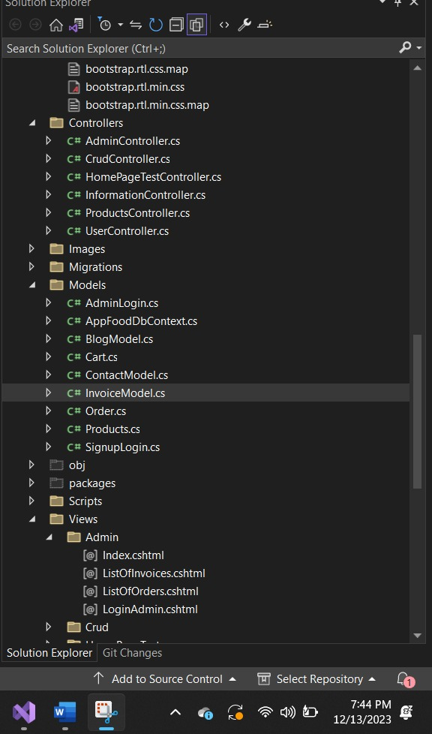
Fig:3.3a
4.Reflection
4.1 Learning Outcomes
I have learned certain new concepts during the development of this project both technically and personally. Technical concepts such as adding DLLs(libraries) into the solution in .Net MVC framework. Adding migrations to the projects for database. Learned how to navigate from model to view and controller to view. Overall I learned to build an optimal application from scratch by attaining good performance and code quality. Apart from Technical point of view I learned to manage the team as a Team lead/manager. I am able to assign the tasks to the team members based on their strengths and weaknesses and also included everyone.

4.2 Teamwork and Collaboration
For the development of this project we had scrum calls ,As a Manager I took the responsibility to get the tasks status from every team mate. Each of us took the responsibility of each functionality and worked collaboratively to achieve the goal. While we had any doubts with design of the project then we approached our senior manager(professor here) to get it sorted. As a project Manager I made sure to have active participation of team in the goal achievement. If there are any conflicts we sat together and discussed among ourselves and resolved them.
4.3 Challenges Faced
One of the major challenges is adding references to get NuGet packages in our framework. We are trying to add references of the packages but unfortunately, they keep on missing after we invested some time on understanding about how to load these references and it’s working functionality. The solution we found to overcome this problem is to unload the entire solution in the visual studio and comment on the DLL which is the root cause of our bug. The solution is simple yet difficult to debug that issue. Like wise there are some small, big and small challenges we faced while developing the application. We collaboratively worked very diligently to build the system. Apart from Technical challenges, If there are any conflicts we sat together and discussed among ourselves and resolved them.
4.4 Skills Developed
Overall I learned to build an optimal application from scratch by attaining good performance and code quality. Apart from Technical point of view I learned to manage the team as a Team lead/manager. I learned how to manage time i.e Time management, Communication skills, Stress Management ,Coding Skills, Problem Solving skills, Team work management. As a Manager I personally learned Leadership quality and Adaptability.

4.5 Future Application
As part of future scope, we will move the application to work android and ios as well by making certain enhancements. Also, with the skills I achieved in future I could be able to work for an organization very diligently and easily. Also as team manager I could be able to manage team very well in real time world.
5.Conclusion
I learned how to manage time i.e Time management, Communication skills, Stress Management ,Coding Skills, Problem Solving skills, Team work management. As a Manager I personally learned Leadership quality and Adaptability. Overall I learned to build an optimal application from scratch by attaining good performance and code quality. Apart from Technical point of view I learned to manage the team as a Team lead/manager. I am able to assign the tasks to the team members based on their strengths and weaknesses and also included everyone.
6.References
https://learn.microsoft.com/en-us/dotnet/csharp/tutorials/ranges-indexes
https://dotnet.microsoft.com/en-us/download/dotnet-framework
https://learn.microsoft.com/en-us/dotnet/framework/migration-guide/versions-and-dependencies

